Sounds through solids, liquids and gases

Aim

To investigate whether sound will travel through empty space, through solids, and through liquids, as well as through gases (like air).
Equipment
Activity A
_ electric bell in bell jar
connected to vacuum pump
Activity B
_ radio or cassette player sealed in plastic bags
_ container of water
_ hydrophone (optional)

A The bell jar experiment
Watch carefully as your teacher shows you an experiment with an electric bell inside an airtight jar.
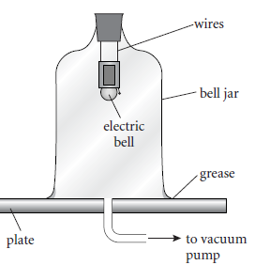
Questions
1 Why is it important that the jar is airtight?
2 How are small gaps around the jar sealed?
3 What is the space inside the empty jar called once the air is pumped out?

4 Could you hear the bell:
a before the air was pumped out?
b after the air had been pumped out?
c when the air was let back in?
5 How did you know the bell was still ringing if you couldn’t hear it?

Analyse
6 What did this experiment tell you about the way sound travels?
7 What did it tell you about the way light travels?
B Sounds through water
Listen carefully to the sound as the radio or cassette player wrapped in
plastic bags is immersed in water.
If a hydrophone is available, use it to listen to the sound under the water.
Questions
8 Could you hear the radio inside the bag before it was put in the water?
9 Could you hear the radio once it was immersed in water?
10 If you could hear it, did it sound different?
11 Did it sound any different through the hydrophone?
Analyse
12 What did the experiment tell you about how sound travels through water?

